Station 4  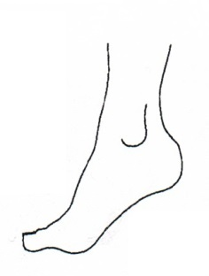 | ________________  ________________  ________________  ________________  ________________
Station 3 | ________________  ________________  ________________  ________________  ________________
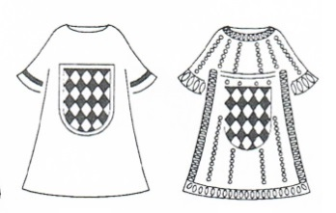  Station 1 | ________________  ________________  ________________  ________________  ________________  Opfer- und Weihegaben  von Maximilian I. (1573-1651)
Station 2 | ________________  ________________  ________________  ________________  ________________

Station 5            

